React Lab Report - StudentApp

# Introduction

In this lab, I explored the fundamentals of React components by building a simple Student Management Portal. I created and rendered multiple components in a React application and understood the usage of both class and function components.

# Objectives and What I Learned

## Explain React components

React components are the building blocks of any React application. They allow you to split the UI into independent, reusable pieces.

## Identify the differences between components and JavaScript functions

Components return JSX and maintain their own state, whereas JavaScript functions are used for computation and logic.

## Identify the types of components

There are two main types of components in React: Class Components and Function Components.

## Explain class component

A class component is a JavaScript class that extends React.Component and must include a render() method that returns JSX.

## Explain function component

Function components are simpler and are just JavaScript functions that return JSX. With hooks, they can also have state and lifecycle features.

## Define component constructor

The constructor is a special function used in class components to initialize state and bind event handlers.

## Define render() function

The render() function is used in class components to describe what should be rendered to the UI.

# Hands-on Practice Summary

I created a React project named 'StudentApp' using create-react-app. Inside the project, I created a folder called 'Components' which contains three components: Home, About, and Contact. Each component displays a simple welcome message. I then imported and rendered these components in App.js.

# Code Snippets

Below are the code snippets I used in the project:

## App.js

import './App.css';  
import { Home } from './Components/Home';  
import { About } from './Components/About';  
import { Contact } from './Components/Contact';  
  
function App() {  
 return (  
 <div className="container">  
 <Home />  
 <About />  
 <Contact />  
 </div>  
 );  
}  
  
export default App;

## Home.js

import React from 'react';  
  
export function Home() {  
 return (  
 <div>  
 <h1>Welcome to the Home page of Student Management Portal</h1>  
 </div>  
 );  
}

## About.js

import React from 'react';  
  
export function About() {  
 return (  
 <div>  
 <h1>Welcome to the About page of Student Management Portal</h1>  
 </div>  
 );  
}

## Contact.js

import React from 'react';  
  
export function Contact() {  
 return (  
 <div>  
 <h1>Welcome to the Contact page of Student Management Portal</h1>  
 </div>  
 );  
}

# Screenshot

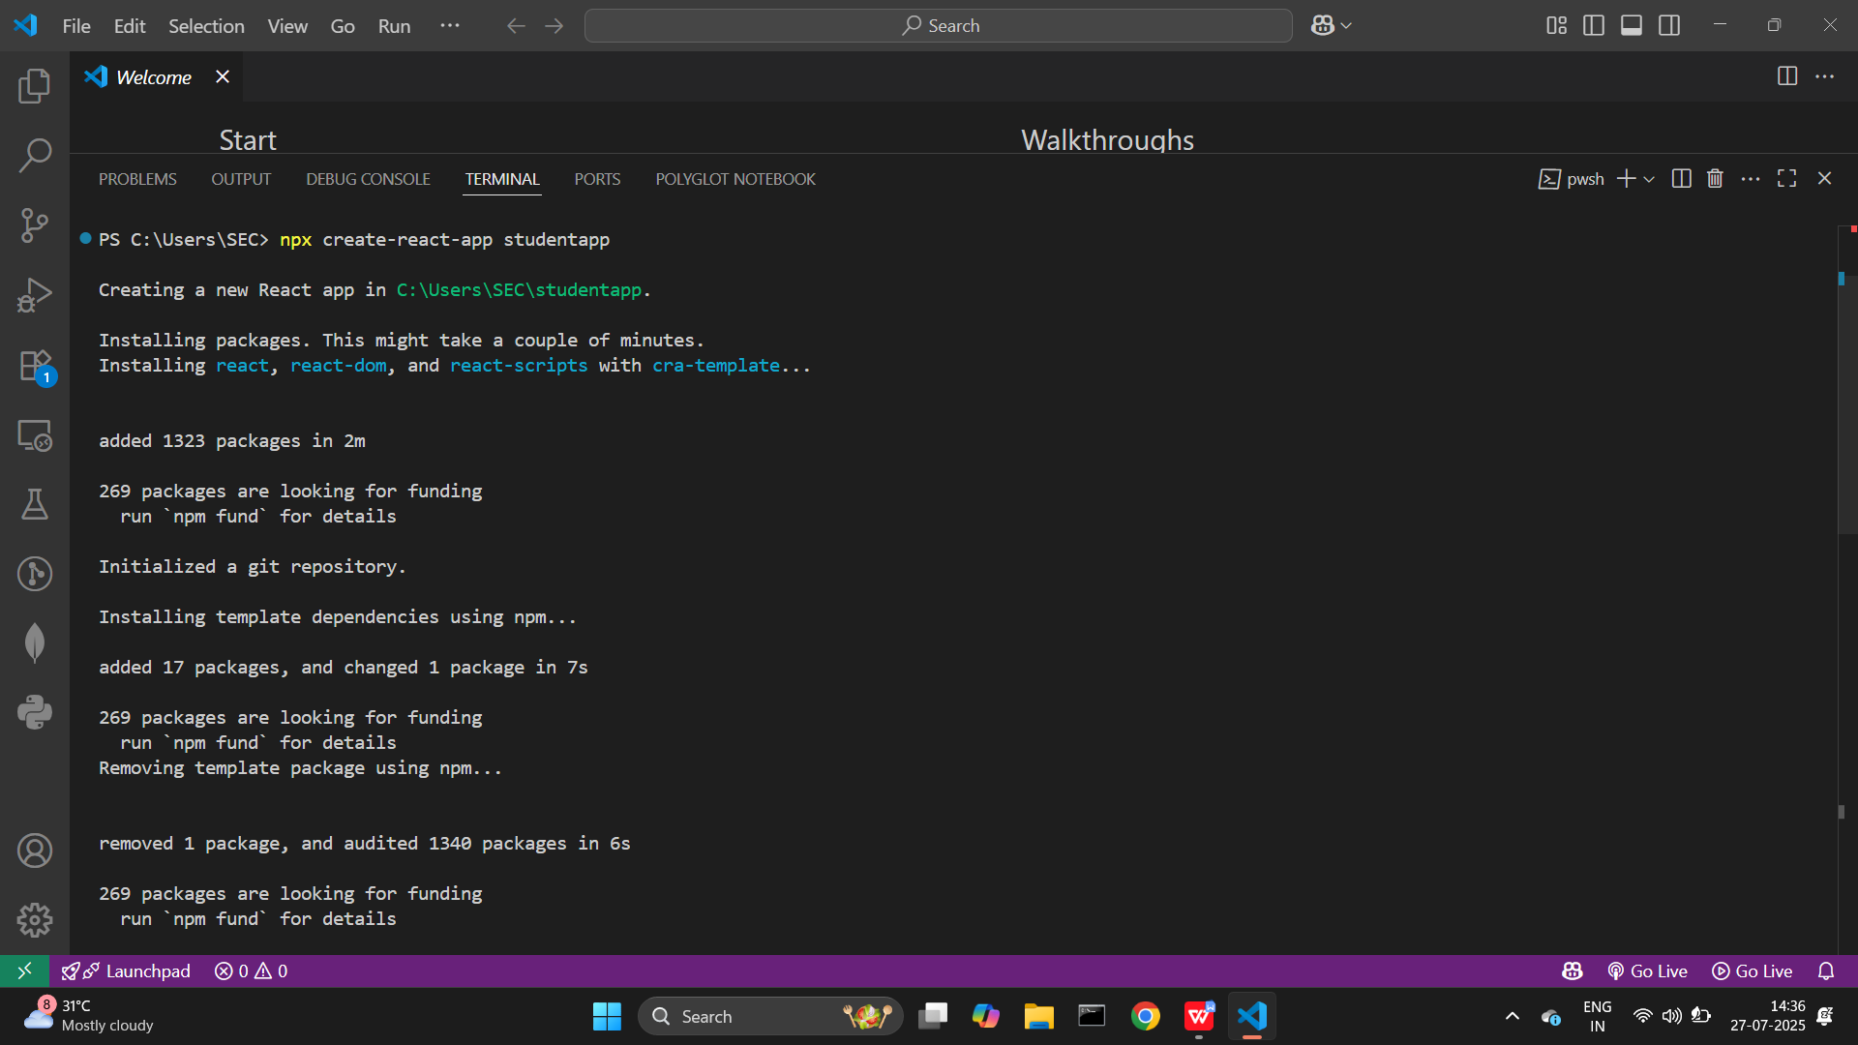

import './App.css';

import { Home } from './Components/Home';

import { About } from './Components/About';

import { Contact } from './Components/Contact';

function App() {

  return (

    <div className="container">

      <Home />

      <About />

      <Contact />

    </div>

  );

}

export default App;

# Screenshot 2025-07-27 151444

# Conclusion

This hands-on helped me understand the structure of a React application and how components are created, managed, and rendered. I now feel confident working with class and function components in React.